Project CM

Software Requirements Specification

Version 1.1

Revision History

|  |  |  |  |
| --- | --- | --- | --- |
| **Date** | **Version** | **Description** | **Author** |
| 09/Oct/2013 | 1.0 | Initial creation | Storm Cloud Development |
| 14/Oct/2013 | 1.1 | Updated: 2.6 Use-Case Model | Storm Cloud Development |
|  |  |  |  |
|  |  |  |  |

Table of Contents

1. Introduction 4

1.1 Purpose 4

1.2 Scope 4

1.3 Definitions, Acronyms, and Abbreviations 4

1.4 References 4

1.5 Overview 4

2. Overall Description 4

2.1 Product Environment 4

2.2 Product Functions 4

2.3 User Characteristics 5

2.4 Constraints 5

2.5 Assumptions and Dependencies 5

2.6 Use-Case Model 5

3. Specific Requirements 6

3.1 Functional Requirements 6

3.2 Supplementary Requirements 6

3.2.1 Usability 6

3.2.2 Supportability 6

3.2.3 On-line User Documentation and Help System Requirements 6

3.2.4 Applicable Standards 6

4. Supporting Information 6

4.1 Glossar 6

4.2 Appendix 6

Software Requirements Specification

# Introduction

## Purpose

This document is intended to help all project members to understand and accomplish their tasks. For this purpose, all functional and non-functional requirements of Project CM are listed and described shortly.

## Scope

The software provides the user an email client and a calendar. The user has the possibility to access his mails and calendar from everywhere if he is connected to the internet. The user can view his appointments and emails on the same webpage. It’s also possible to retrieve mails from other servers and store them on the application server.

## Definitions, Acronyms, and Abbreviations

SRS Software Requirements Specification

Project CM The email client and calendar project (name)

CRUD create, read, update, delete

## References

n/a

## Overview

The SRS first gives a general overview over the product with its functions and requirements and explains them more detailed afterwards.

# Overall Description

## Product Environment

It is required to have an internet connection and one of the latest versions of a common internet browser.

## Product Functions

The calendar and the mail client are mainly designed for home users.

## User Characteristics

No special knowledge is needed to use this application.

## Constraints

n/a

## Assumptions and Dependencies

n/a

## Use-Case Model

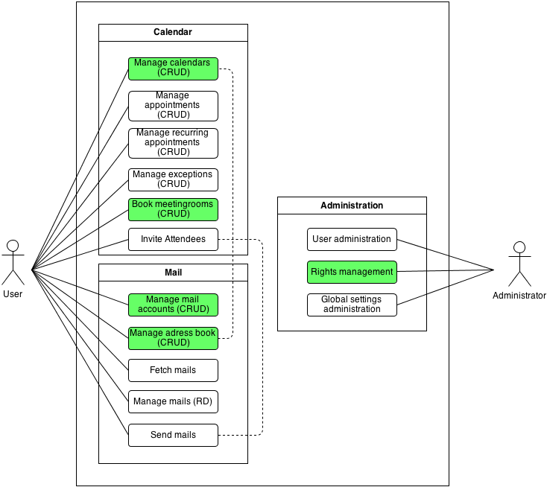

**Manage calendars:** The user can CRUD calenders.

**Book meeting rooms:** User can CRUD bookings of meeting rooms.

**Manage mail accounts:** The user can CRUD mail accounts.

**Manage adress book:** The user can CRUD personal contacts in his adress book.

**Rights management:** The administrator can assign roles to users. He can specify rights for this role.

# Specific Requirements

## Functional Requirements

Manage calendars: see “UC_manage_calendars.pdf”

Book meeting rooms: see “UC_book_meeting_rooms.pdf”

Manage mail accounts: see “UC_manage_mail_accounts.pdf”

Manage adress book: see “UC_manage_adress_nook.pdf”

Rights management: see “UC_manage_rights.pdf”

## Supplementary Requirements

### Usability

* The user interface must support at least German and English as language

### Supportability

* Occurring bugs must be fixed
* A contact possibility must be provided for the users

### On-line User Documentation and Help System Requirements

* A online help should be available

### Applicable Standards

n/a

# Supporting Information

## Glossar

n/a

## Appendix

n/a